Software Requirements Specification Template

Shopping Buddy

Software Requirements Specification

Version 1.0
06/11/2019

Vennela Cheekoti
Sathwika Gone
Susritha Gade
Rakesh Avirineni
Yaswanth Yarram
Sandeep Devineni
Mehar Choudhary Meenavilli

Submitted in partial fulfillment
Of the requirements of
CSIS 44-691 Graduate Directed Project 1

Revision History

Date | Description | Author | Comments
06/11/2019 | Version 1.0 | Vennela Cheekoti  Sathwika Gone  Susritha Gade  Rakesh Avirineni  Yaswanth Yarram  Sandeep Devineni  Mehar Choudhary Meenavilli | First Revision

Document Approval
The following Software Requirements Specification has been accepted and approved by the following:
Signature | Printed Name | Title | Date

Table of Contents Page Number
1. Introduction
1.1. Purpose
1.2. Scope
1.3. Definitions, Acronyms, and Abbreviations
1.4. References
1.5. Overview
2. General Description
2.1. Product Perspective
2.2. Product Functions
2.3. User Characteristics
2.4. General Constraints
2.5. Assumptions and Dependencies
3. Specific Requirements
3.1. External Interface Requirements
3.1.1. User Interfaces
3.1.2. Hardware Interfaces
3.1.3. Software Interfaces
3.1.4. Communications Interface
3.2. Functional Requirements
3.3. Use Cases
3.4. Class/Objects
3.5. Non-Functional Requirements
3.5.1. Performance
3.5.2. Reliability
3.5.3. Availability
3.5.4. Security
3.5.5. Portability
3.6. Inverse Requirements
3.7. Design Constraints
3.8. Logical Database Requirements
3.9. Other Requirements
3.10. Prototypes (for complete project)
3.11. Use Case Diagrams
4. Design
4.1. ER diagram
4.2. GUI
5. Analysis Models
5.1. Data Flow Diagram
5.2. Sequence Diagram

1.Introduction
1.1. Purpose
The purpose of this project is to create a user-friendly e-commerce application which allows the user to shop online and place the order and receive those orders.
1.2. Scope
This is an e-commerce application with a login page, if the user is new to the application then he will be allowed to register. User can browse through the different categories(Clothing, Household, Furniture, etc.) and place their order after that user will be redirected to the payment, once payment is done user order is placed successfully and the user will know about when their order will reach.
1.3. Definitions, Acronyms, and Abbreviations
1.4. References
1.5. Overview

2. General Description
2.1 Product Perspective
Shopping Buddy is an application used for online shopping developed using open source technologies. This application provides a simple mechanism for users to buy new things and order them online. Some of the main features included in this application are
- User Account: Our application allows the user to create their accounts in the system and provide features of updating viewing their profiles.
- Features & Specifications: The user can get to know about every features and specification of a particular product.
- Number of users being supported by the application: Though the number is not mentioned but our application supports a good number of users at a time
- Review: The user is able to review the particular product before the user orders.
Since this is a data-centric product it will need a database to store the data. We add and modify the data whenever needed. All the database communication will go over the internet.
2.2 Product Functions
With this product, the uses are able to go through the different products available. The user is provided with an account where the user is able to know the deals available and orders. Also, the users can add their desired items into the cart. Additionally, we also provide some coupons to the user which are helpful in getting the reduced price.
2.3 User Characteristics
The users can use this application with and without logging into the application and can see the details and reviews of the various products present but during the checkout i.e when the user is about to pay for the product, the user must log into the application to proceed with the payment.
2.4 General Constraints
The internet connection is a constraint for this application. Since the application fetches the data from the database over the internet, it is important to make sure that there is an internet connection for the application to function.
2.5 Assumptions and Dependencies
We assume that the application will always work on mobile phones that have enough performance. If the mobile does not have enough hardware resources available for the application, like if the users might have allocated them with other applications, there may be situations where the application does not work.

3. Specific Requirements
3.1. External Interface Requirements
3.1.1. User Interfaces:
A good user interface provides a "user-friendly" experience, allowing the user to interact with the software or hardware in a natural and intuitive way. The GUI of our software program includes many controls like the menu bar, Input selector, keyboard, icons, images, and buttons.
3.1.2. Hardware Interfaces:
This application works on Android device. No other hardware is required.
3.1.3. Software Interfaces:
- IDE: Android Studio
- Virtual Device: GVD(GenyMotion)
3.1.4. Communications Interface:
This application uses Wi-Fi Direct to communicate Android devices.

3.2 Functional Requirements
Registration screen:
Registration screen can be used by the novice user for registering into the application.. In this screen the user need to enter Username, Contact number, Email, Password and Confirm password for registration.
Login screen:
Login screen can be used by the registered user for logging into the application. In this screen, the user must enter the Username and Password to get into the application. This screen has Forgot Password feature which leads the user to reset their password.
Home screens:
Here the user can view the products. The user can find a particular product by selecting a product category in the menu. Each product has a product picture and description.This screen has “add to cart” feature where users can add the desired product to the cart so that the users can view the items later on.
Share item:
In this screen, by using the share button the user can share the product to other users.
Order list:
List of items which are about to purchase can be viewed in the order list screen.
Rating and review:
The user can give review and rating for the product.
Deals:
Here the user can view current deals of Shopping Buddy application.
Promotional codes:
When the user enters the promo code while purchasing the items, then the user gets the discount on the purchase cost.
Payment page:
To purchase items the user must enter the card number, the expiration date of the card and CVV number.
Menu:
In the menu, the user can view all the categories in the application.
Contact us:
In this screen, the user can view the contact information.
Add products/Delete Products:
Admin can add/delete the products into the application.
Add/Delete promotional codes:
Admin can add/delete promotional codes.
3.3. Use Cases
3.4. Class/Objects
3.5. Non-Functional Requirements
3.5.1. Performance:
Requirements about resources required, response time, transaction rates, throughput, benchmark specifications or anything else having to do with performance.
3.5.2. Reliability:
Requirements about how often the software fails. The measurement is often expressed in MTBF (mean time between failures). The definition of a failure must be clear. Specify the consequences of software failure, how to protect from failure, a strategy for error detection, and a strategy for correction.
3.5.3. Availability:
Availability is gauged by the period of time that the system’s functionality and services are available for use with all operations.
3.5.4. Security:
One or more requirements about the protection of your system and its data. The measurement can be expressed in a variety of ways (effort, skill level, time, ...) to break into the system.
3.5.5. Portability:
The effort required to move the software to a different target platform. The measurement is most commonly person-months or % of modules that need changing.
3.6. Inverse Requirements
3.7. Design Constraints
3.8. Logical Database Requirements
3.9. Other Requirements
3.10. Prototypes (for complete project)
Login/Register: User have to register or login into the application before paying their amount.
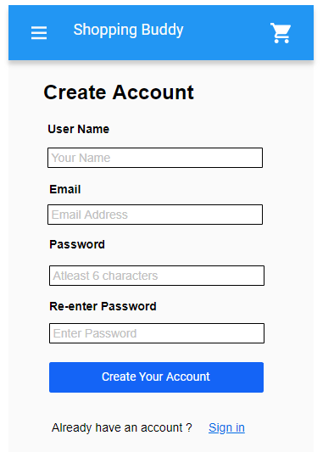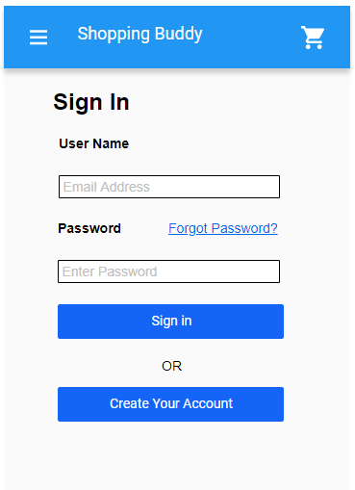
Home screen: Some random products are displayed on this screen.
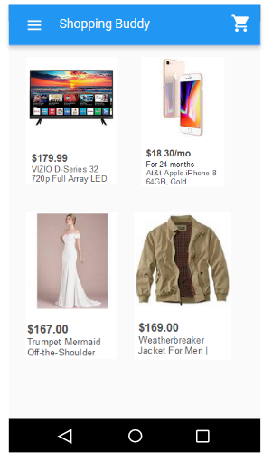
Menu: Shows the categories of the products.
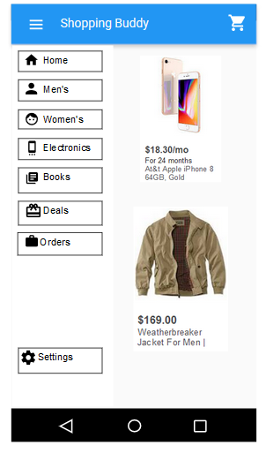
Products: This page displays all the products of the category selected by the user.
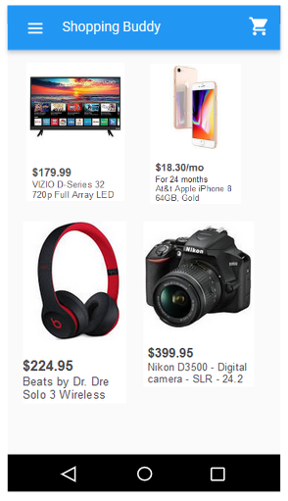
Product description: This page shows the product name, description, price and rating. User can also share the product by clicking on the share option.
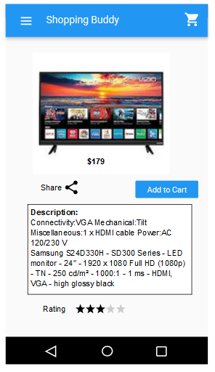
Cart: This page shows all the products added to the cart by the user. User can increase or decrease the quantity and can also remove the product from the cart.
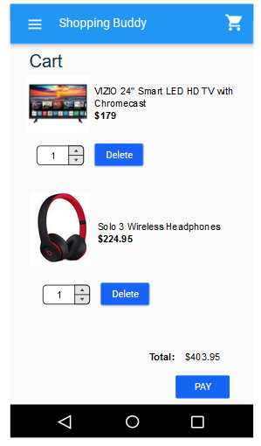
Shipping Address: User have to enter the shipping address before checkout.
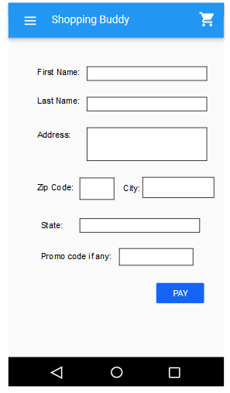
Payment: User have to enter their card details.
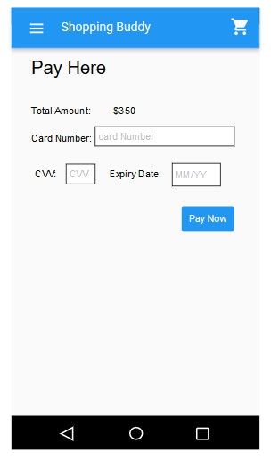
Orders: This page shows all the orders made by the user.
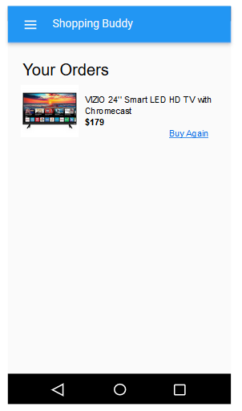
Settings: This page displays a menu where a user can see or reset their private information. User can also see contact details for this application.
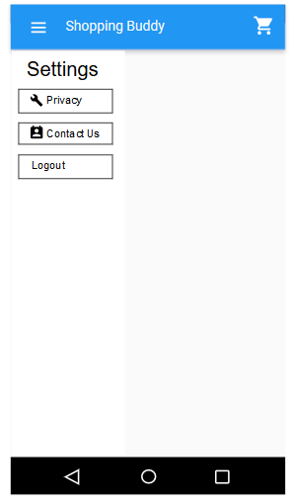
Privacy: This page helps the user to see or reset their details.
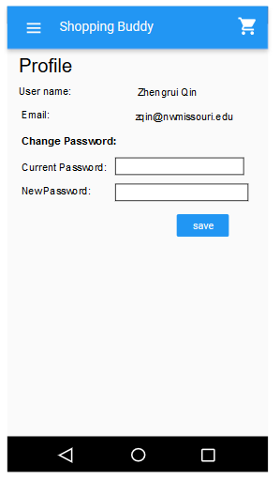
Contact Us: This page displays contact information of the customer support.
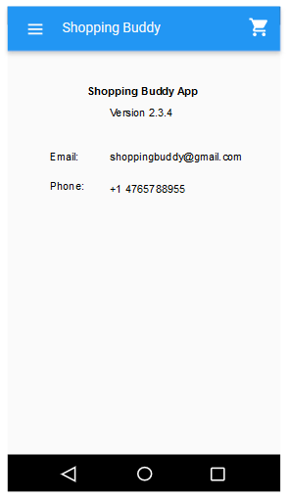

Admin Pages:
Add product: This page allow admit to add the products by entering product id, product name, product description, product picture, product category and product price.
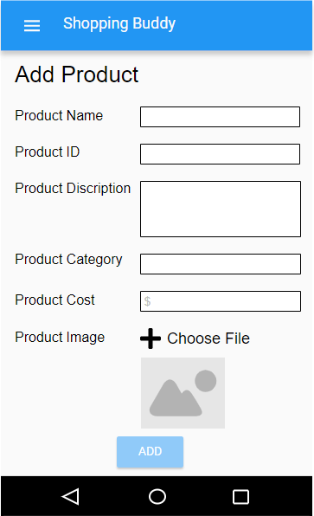
Remove Product: This screen allows the admin to remove product by entering product id and product name.
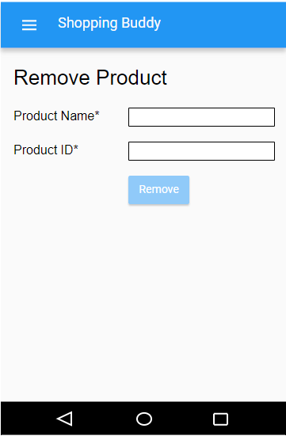
Add/Delete Promotional Code:This screen allows the user to add/delete the promo codes by entering promo code id and promo code.
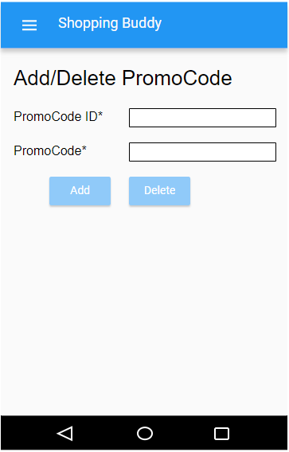

3.11. Use Case Diagram
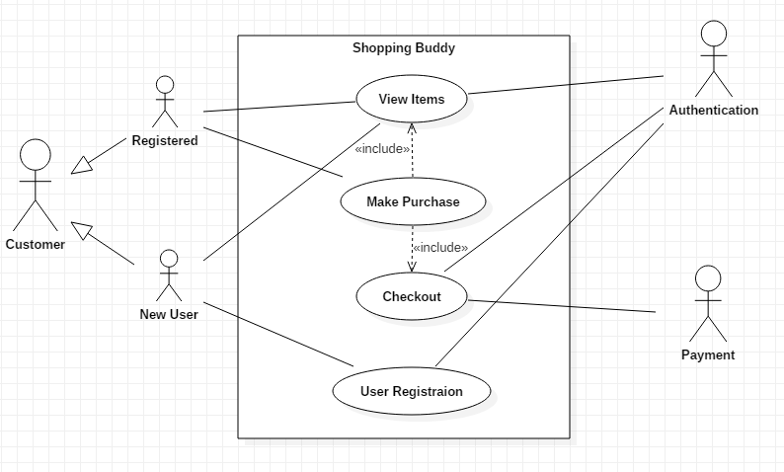

4. Design
4.1 ER Diagram:
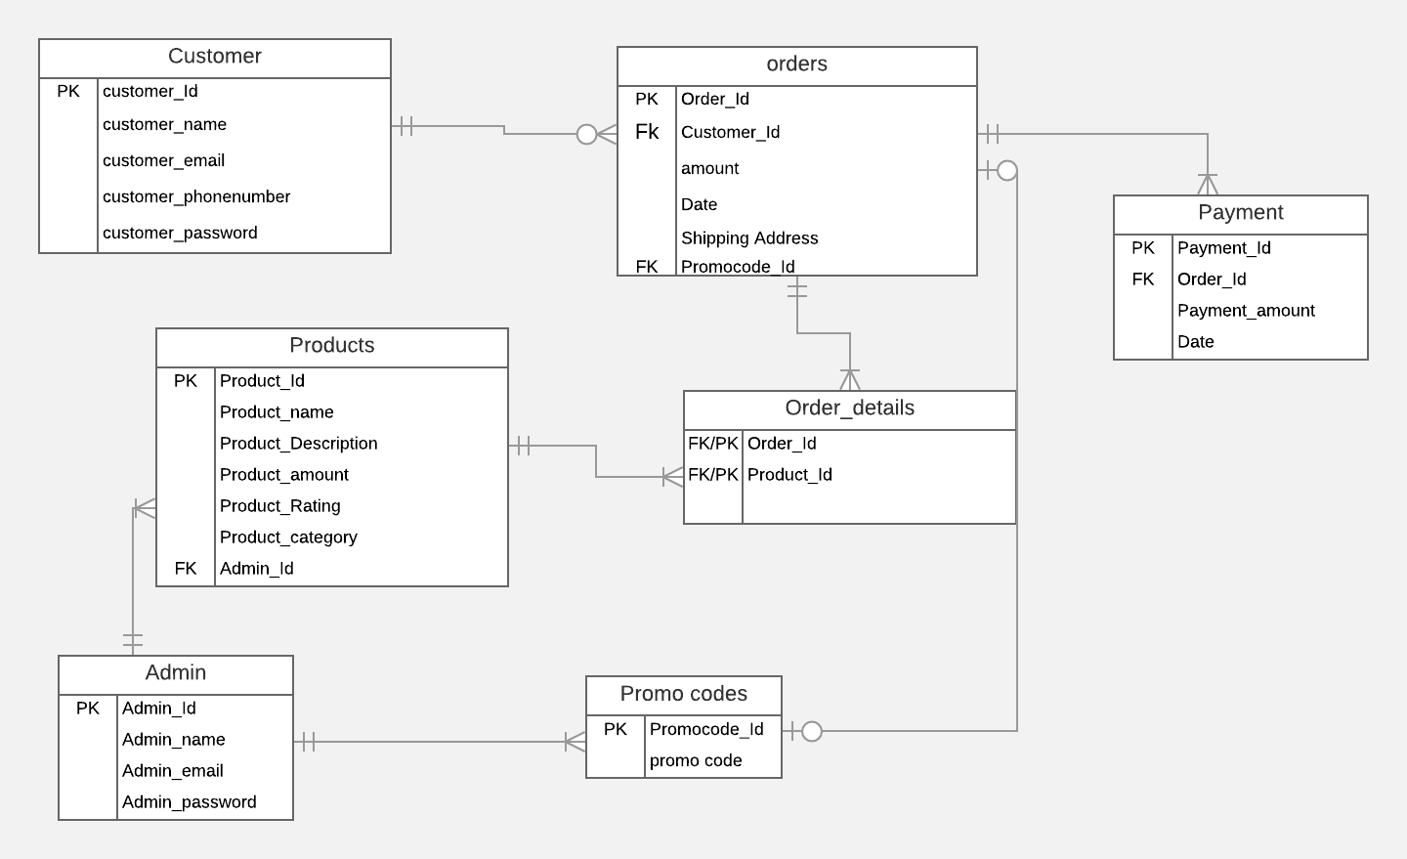
In the above Entity Relationship diagram, it has 7 entities namely Customer, Products, Admin, Orders, Order_details, Promo codes and payment. The customer can be considered as user and admin can be considered as seller. From the above diagram we can also see that we have only one associative entity that is Order_details which is a weak entity. Customer_id, Product_id, Admin_id, Order_id, Promocode_id, Payment_id are primary and foreign keys.
Relationship:
Customer: Orders - 1: M
Orders: Payment - 1: M
Orders: Order_details - 1: M
Product: Order_details - 1: M
Orders: Promo codes - 1:1
Product: Admin - 1: M
Admin: Promo codes - 1: M

